Dear Parent/Carer

Welcome to Ballykelly Nursey & Primary School. We have a long and rich history dating back to Plantation Days. When originally established, the school served the needs of the whole community and that proud tradition is still carried on today. Children of all races, faiths and backgrounds are educated together in a warm and welcoming atmosphere where mutual respect and acceptance underpin the school’s caring ethos.

To find out more about our Nursery and Primary School, we have made two short promotional films that you can watch by scanning the QR codes or by visiting YouTube Ballykelly Primary School.

Visit our website for further information including the Admissions section and the Nursery and Year Group sections that showcase school life.

[www.ballykellyps.co.uk](http://www.ballykellyps.co.uk)

You can also find us on Facebook to view regular updates on school events.

Ballykelly Nursery Unit

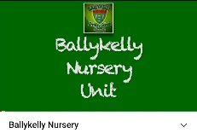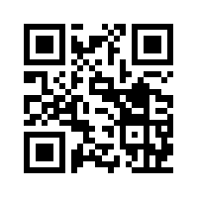

Scan the QR Code or use the link above to watch our promotional short film about our Nursery Unit.

<https://youtu.be/HG9qUMUq-60>

Ballykelly Primary School

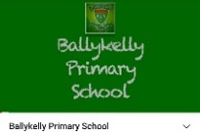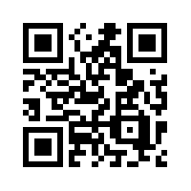

Scan the QR Code or use the link above to watch our promotional short film about our School.

<https://youtu.be/dItzTxBhGJY>

(You can also find this link on the school website in the Admissions section)

***We are here to help if you need any further information about our Nursery or School. Telephone 028 777 62864 or email*** [***hcole272@c2kni.net***](mailto:hcole272@c2kni.net)

**Open Enrolment Timetable for Nursery and Primary One – September 2021**

* **Friday 18th December 2020-** EA publishes information on website about the pre-school admissions procedure and admissions criteria for schools/providers

[www.eani.org.uk/admissions](http://www.eani.org.uk/admissions)

* **Thursday 7th January 2021-** Nursery & Primary One application procedure opens at 12 noon with online portal available
* **Friday 29th January 2021-** Application procedure closes at 12 noon
* **Friday 5th February 2021 up to 12 noon-** Final date a parent can provide documents to 1st preference school including any new additional supporting information for any preferences listed that was not available at time of application
* **Tuesday 27th April 2021-** Parents receive notification of outcome of P1 applications via online portal

**EA Admissions Helpline for parents**

**Tel: 028 9598 5595**

**Monday – Friday**

**9:00am – 5:00pm**

**Building firm foundations in Nursery,**

**Primary 1 and Primary 2.**

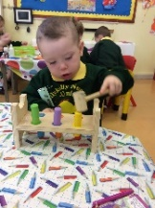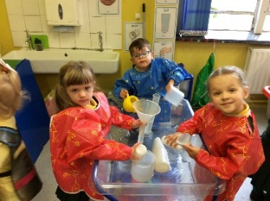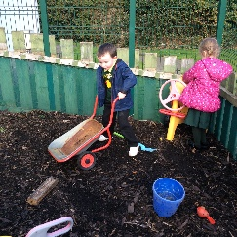During the early years at Ballykelly Primary School and Nursery the children have the opportunity to learn through play with an emphasis on developing children’s language and communication skills. Children have the opportunity to be creative, use their imagination, develop independence and establish friendships.

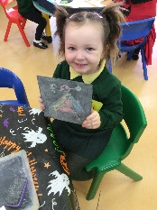

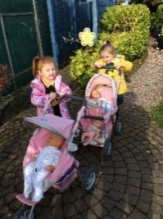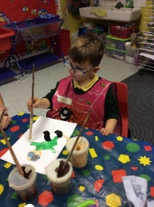

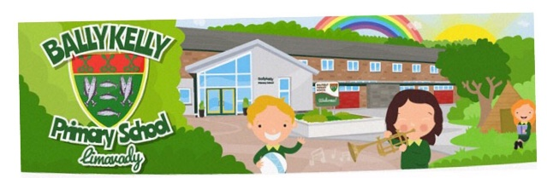

**Ballykelly Primary School**

**8 Glenhead Road**

**Ballykelly**

**BT49 9JS**

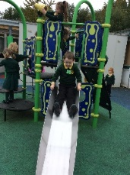**Tel: 028 777 62864**

**Email:** [**info@ballykelly.limavady.ni.sch.uk**](mailto:info@ballykelly.limavady.ni.sch.uk)

[](http://www.bing.com/images/search?q=eco+schools+logo&id=46888EC19A51DCE0F5EAB6FAB23E6EA7C2B66C97&FORM=IQFRBA)**Website:** [**www.ballykellyps.co.uk**](http://www.ballykellyps.co.uk)

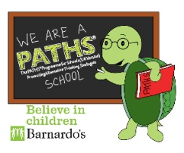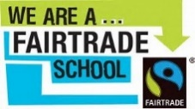

**[](http://www.bing.com/images/search?q=Accelerated+Reader+logo&id=BCE5035C25F91D667D2FA3D80B9E4E38472F9BFD&FORM=IQFRBA)**

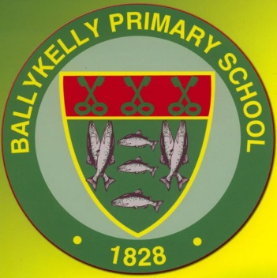

**Ballykelly Primary School**

**& Nursery Unit**

**Principal: Mrs Helen Cole MBE**

**Information on Open Enrolment for Nursery and Primary 1 2020/21**

“*Our mission above all is to provide* *a caring secure environment where individuals of all backgrounds, races and religions can feel welcomed and valued and are encouraged to learn and develop to their full potential*.”

**\*\*Due to Covid-19 restrictions, schools are unable to host open days or evenings\*\***