Ballykelly Primary School

Positive Behaviour Policy

Reviewed by staff August 2022

Presented to B.O.G October 2022

Policy Review Date 2023-2024

Ballykelly Primary School
Positive Behaviour Policy

Rationale

Our Positive Behaviour Policy is an intrinsic part of our overall Pastoral Care Programme and aims to ensure that children in Ballykelly Primary School are educated in safe, secure and caring environment.

We accept that:

- each child is an important person and entrusted to us by their parents

- every member of staff is an important person and a professional, entitled to the support and respect of children and parents.

We also believe that good discipline is based on good relationships between pupil and teacher and high expectations of pupils in terms of behaviour and work. Ballykelly Primary seeks to promote its aim of being a ‘listening school’ in the development of friendly relationships at all levels.

- Behaviour Policy Introduction

As part of the caring ethos of our school we feel that it is important that we provide a supportive framework for children as they learn how to care for and respect themselves and others. An integral part of this framework involves positive expectations and clear guidelines for acceptable behaviour together with praise and encouragement. We acknowledge the crucial link between high self esteem and successful social interaction and any sanctions will be used thoughtfully in order to keep self-esteem intact.
In their time with us, children will be learning how to take responsibility for their behaviour. This involves reaching an understanding that our actions have consequences. We recognise that this is a learning process and that children will progress at different rates and will need different levels of support. As well as having their positive behaviour acknowledged, children need to be aware of what constitutes unacceptable behaviour and to know that this also has consequences, thus a graded system of sanction forms part of our policy.

- Aims of the School

Underpinning this policy are the aims and values of our school mission statement:

“Our mission above all is to provide a caring secure environment where individuals of all backgrounds, races and religions can feel welcomed and valued and are encouraged to learn and develop to their full potential.”

Values
At Ballykelly Primary School every child matters and each individual is valued for the unique contribution he or she makes to our community. We expect everyone to show respect for others, to be courteous, responsible and caring, and we actively foster such behaviours. Our aim is to create an environment which promotes children’s self-esteem, to make our school a place where pupils feel happy, safe and able to enjoy learning. We strive to provide a learning climate in which children can flourish and achieve their very best, where they can celebrate their differences and develop the skills and confidence to build happy and successful futures. By working closely with parents and the community we aim to build strong and effective partnerships, which help children to thrive.
Our School Core Values are as follows:
Value | Description
High Expectations | We will have high expectations of ourselves and others. We will believe that we can be the best we can possibly be. We will be proud of our unique skills and qualities. We will always try our best and will focus on ways we can improve our lives and the lives of others.
‘Give it a go’ attitude | We will approach all challenges with a positive mind-set and a ‘Give it a go’ attitude. As long as we have a go we will be happy that we have tried.
Respectful | We will be respectful of ourselves and others. We will respect each other’s faiths, beliefs, views and opinions. We will also respect each other’s property and that of the school.
Moral | We will always strive to do the right thing and if we make a mistake we will learn from it.
Inclusive | We will respect and value all members of society. We will be welcoming to all.

Aims
We aim to:
•Create a nurturing environment which supports the well-being of every pupil and enables children to be healthy, emotionally literate and able to maintain positive and fulfilling relationships.
•Provide exciting, engaging and creative learning experiences, which enable all children to become active, independent and effective learners who achieve their very best.
•Develop pupils’ understanding of their responsibilities as members of a community, encouraging a positive, respectful and caring attitude towards others & the environment.
•Enable all our children to become enquiring, responsible, resourceful and reflective young people, ready to face the future with confidence and to challenge themselves.
•Foster strong partnerships with parents and carers, valuing the contributions they have to make, encouraging their active involvement in children’s learning and developing a relationship based on mutual trust.
•Put the school at the heart of the local community, so that both school and village are enriched, and enable children to appreciate aspects of the wider world.

Nurturing School
At Ballykelly PS/NU we fully believe and implement the principles of Nurture. As a nurturing school we
- Take a holistic approach to education
- See emotional wellbeing as central to the development and mental health needs of our pupils
- And to the effectiveness of teaching and learning
- Believe in supporting our families to ensure the best for our pupils

PATHS School
At Ballykelly PS/NU we are proud to be a Barnardos PATHS school. The PATHS® Programme for Schools (UK Version) empowers all children to develop the fundamental social and emotional learning skills which will enable them to make positive choices throughout life.

- Principles underlying this policy

This policy forms an essential part of our overall Pastoral Care Programme. Our Positive Behaviour policy, together with our Personal Development and Mutual Understanding curriculum, is designed to help pupils understand how membership of a community confers duties, responsibilities and rights upon the individual. The aims of this policy are to:
•Encourage good behaviour
•Promote positive attitudes
•Develop moral codes and values
•Prepare pupils for citizenship

The school has a simple code of conduct which sets the standards of behaviour both in class and throughout the shared areas of the school. These are our Golden Rules.

The Golden Rules
• Do be gentle – Do not hurt anyone
• Do be kind and helpful – Do not hurt people’s feelings
• Do work hard – Do not waste yours or other people’s time
• Do look after property – Do not waste or damage things
• Do listen to people – Do not interrupt
• Do be honest – Do not cover up the truth
• Do move safely around the school – Do not run indoors

4. Roles and Responsibilities

The Role of Governors

Governors will:

- have overall responsibility for ensuring a Behaviour Policy is in place;

- set down general guidelines on standards of discipline and behaviour;

- review their effectiveness;

- support the Principal in carrying out these guidelines.

The Role of the Principal

The Principal is responsible for:

- implementing the school behaviour policy consistently through out the school;

- reporting to governors, when requested, on the effectiveness of the policy;

- ensuring the health, safety and welfare of both staff and pupils in the school;

- keeping records of all reported serious incidents of misbehaviour;

- giving fixed-term suspensions to individual children for serious acts of misbehaviour

- expelling a child for repeated or very serious acts of anti-social behaviour.

In the case of suspension or expulsion the Board of Governors will implement EA Western Regions Suspension and Expulsion Policy and work with EA Western to ensure these procedures are followed.

The Role of the Class Teacher
Class teachers will:

- plan lessons with clear aims and objectives;
- Keep parents informed of any issues

- maintain high, realistic expectations of pupils;

- be consistent and fair;

- treat all children with respect and understanding

- liaise with external agencies to support and guide progress of each child e.g. SENCO, Psychologist etc.;

- establish a purposeful listening environment in their classroom;

- praise pupil’s achievement as often as possible;

- reward good behaviour in and out of the classroom.

- Promote good behaviour (model desired behaviour / catch them being good / Circle Time / Golden Time)

The Role of Positive Playground Team

The Playground Team is responsible for:
- organising Playground Zones
- Dealing with 2nd sanction and liaising with class teacher
- Leading an assembly (Early Sept) informing pupils about the playground zones and acceptable behavior and the consequences/ sanctions
- Liaising with lunchtime staff (Lunch time supervisors and CAs)

The role of support and lunch time staff
- Have high expectations of all children.

- Encourage, praise and listen to children.

- Follow positive behaviour procedures to ensure a consistent and fair approach.

- Evaluate the factors which can contribute to negative behaviours and seek to provide high levels of engagement, opportunities for speaking and listening and practical demonstration of learning (learning by doing, rather than learning by do not).

- Adopt the language of choices to de-escalate a volatile situation and seek the advice of the class teacher should the situation not be resolved (see Appendix 2).

The Role of Pupils

Pupils have the right to be taught effectively in a proper environment, to experience a well balanced curriculum and to be treated positively and fairly;

We expect our pupils to:

- be co-operative and well mannered;

- to respect others and to contribute positively to school life;

- be familiar with the School’s Golden Rules, the Code of Conduct for the Canteen/Playground and Bus (Appendix 1) and the implications of above codes for their behaviour.

Children with Special Educational Needs
We expect all children to follow the Golden Rules. As much as possible, we wish to keep the children with special educational needs within the Code of Conduct. However, this will be more difficult for some children at certain times. Children with behaviour difficulties on the SEN Register may:
- have regular meetings with their teacher and parents/carers.
- be placed on report by members of Senior Leadership working with that child and class teacher. A mutual decision is made, involving the child, as to when the form is deemed no longer necessary. Parents/carers see the form weekly.
- have targets for improved behaviour on their PLP.
- have an Individual Behaviour Plan.
- meet regularly with the SENCO to discuss progress.

Children who have a full Statement of Special Educational Needs may need the Code of Conduct to be modified to manage their behaviour. Some pupils may not comprehend the rules and structures of the school and be unable to meet expectations with additional support. A formal meeting should take place each term between parents/carers, school staff and relevant outside agencies.

The Role of Parents

Parents have the right to adequate information, to be listened to and to know that their children will be safe, secure and properly taught.
In return we expect parents to:

- ensure their child attends school regularly and punctually;

- monitor child’s progress/see that all homework is completed;

- offer relevant information regarding personal needs

- meet with staff when necessary;

- support school policies;

- ensure child is in proper uniform.

- Rewards For Positive Behaviour
It is important that the positive aspects of praise and rewards should have great emphasis. Evidence suggests that better standards of behaviour are achieved where there is a healthy balance between rewards and sanctions and good behaviour is rewarded.

Guiding principles - Rewards are intended to:
- reinforce the behaviour we expect
- boost the self-esteem of individuals
- help children to learn that the consequences of good behaviour are pleasurable,
- deserve recognition and are valued in school in the same way as academic effort and achievement.

Types of reward
Pupils who uphold the aims and values of the school may be rewarded in a variety of ways:
- Non-verbal rewards – e.g. smiles, thumbs up
- Verbal or written praise from the class teacher or supervising adult.
- Awarding of privileges or posts of responsibility.
- Stickers and certificates of achievement from the teacher or supervising adult.
- KS2 Achievement Sticker Record Book leading to homework passes.
- Sharing work or event in assembly.
- Certificates for Core Values
- Verbal praise, written comments on work and awards from Headteacher.
- Note sent home to parents.
- Homework pass.
- Golden time, which is thirty minutes each week when pupils choose their activity. This is a basic reward for all unless it has been removed as a sanction.
- Star of the week: One child per class is chosen each week and commended during whole school assembly.
- Accelerated Reader Programme KS2- 100% sticker, monthly prize draw and termly target prizes.

- Sanctions for unacceptable behavior in the classroom and school playground
(All classes will have “every day is a new day” policy.)
Each Key Stage use a three Band System (Rules, Rewards, Consequences)

All parents will undoubtedly recognise that the learning process will flourish better in the positive and well disciplined atmosphere which we aim to encourage and maintain.

However, there are occasions whenever unacceptable behaviour emerges. This cannot be tolerated under any circumstances because it is not in the best interests of that child nor the rest of the children.

Sanctions adopted will take account, not only of the “incident”, but the individual circumstances.

Pupils who fail to uphold the aims and values of the school will be sanctioned depending upon the severity or the persistence of their inappropriate behaviour. The following behaviours are unacceptable:

  - Disruption of learning – calling out, interrupting others, causing a disturbance
  - Disrespect and disobedience
  - Dishonesty
  - Swearing
  - Name calling
  - Fighting or violent behaviour
  - Threatening behaviour or bullying
  - Destruction of property
  - Stealing
  - Leaving class without permission
  - Sexual, racial, physical or verbal harrassment

When dealing with unacceptable behaviour, staff should ensure that sanctions / punishment
- Are appropriate to the individual
- Are immediate, consistent and fair
- Are positive i.e. critical of the behaviour but not of the child
Wherever possible, teachers should use de-escalation strategies to manage pupils’ behaviour positively. See Appendix 2.

Sanction | Description
1 | [Issued by class teacher]  - Children will walk with an adult at break and lunch for 1 or 2 days-parent will be informed in writing and asked to sign the Sanction slip [Signature is not compulsory in order for sanction to be implemented]
2 | [Issued by Key Stage Coordinator]  - Child will stay in the nurture room, supervised by Classroom assistant for 3-5 days and break/lunch times-parents will be informed in writing and asked to sign the Sanction slip [Signature is not compulsory in order for sanction to be implemented]  - If a child uses verbal or physical abuse he/she will automatically be issued with Sanction 2  - During the pupils time in the nurture room they will engage in discussion with the adult about why the incident occurred and think about strategies and supportive ways to avoid it happening again. Please see Appendix 5 for examples of restorative conversations
3 | [Issued by Principal]  Parents will be requested to attend a meeting to discuss their child’s behavior and consequences-the child will be placed on a behavior plan and support may be sought for the child through support from outside agencies/PLP plan. It may be necessary to refer to the suspensions and expulsions section of the policy. See Appendix 6 for an example of a Behaviour Plan

PROCEDURES FOR SUSPENSIONS

Before the suspension of a pupil is considered (unless the incident is of a very serious nature) the school will have applied all of its preventative strategies and alternative sanctions. This will include formal contact with the parents to warn them of the possibility of suspension.

The following procedures will then be observed:

1.The formal written record of incidents maintained in the school will be made available to the EWO who will be invited to the school to discuss the situation with the Principal.
2.The Principal and appropriate teachers will be consulted regarding the difficulties and the best way forward.
3.EA Locality Team will be informed using an EW24B form. If appropriate, Social Services will also be notified.
4. The Chairperson of the governors will be informed (or the vice chairman in his/her absence) in writing and a report delivered to the governors at the next meeting.
5.A letter will be sent home with the child outlining:
a) the reasons for the suspension
b) the period of the suspension
c) the work which the parent must undertake during that
period
d) the letter will also invite the parent to meet the principal and
discuss the problem and how the parent can help (A written
record of this meeting will be kept by the school)
e) a copy of the letter sent home with the child will be posted
to the parent by recorded delivery (first class post)

PROCEDURES FOR EXPULSION

This is the ultimate sanction and will only be employed as a last resort. The school recognises that

a) it must produce evidence to EA Western Region that it has exhausted its range of options and strategies.
b) the recommendation for expulsion must come from the Board of Governors
c) except in exceptional circumstances the child will need to have already
served a period of suspension
d) consultations will have taken place between the principal, parent, EA Western Region and the Chairperson of the Board of Governors about future provision for the child

GENERAL MOVEMENT WITHIN THE SCHOOL

- Pupils should arrive by 8.45am and children will be met and greeted by class teacher in the playground

- Pupils should not arrive before 8.00 a.m.[Breakfast Club] (should any incident occur before this period, the School will not be held responsible). From 8- 8.30 children use Main Entrance Door

- Pupils attending Breakfast Club will be given permission to leave at 8.30am and breakfast club will remain open until 8.50am. 1 CA will be on duty

- 2 Adults will be on Duty at 8:30am [Principal/VP/SLT] and will oversee the behavior in the playground and support the pupils entering the classrooms.

- After morning break and lunch the class teacher will collect children from the playground and return to class.

- Children will walk at all times and keep to the left along corridors and stairways

- Children will show respect to all adults – this will include
- step back and make way for any adult you meet in the school.
- hold doors open if appropriate.
- put all litter and scraps in the bins
- keep the cloakroom areas free from litter

SUPERVISION IN SCHOOL

- The Vice-Principal shall organise and maintain a written system of supervision for all pupils and check that scheduled duties are being carried out.
- If a member of staff is ill, the substitute teacher should perform any duties assigned to that teacher.
- If a member of staff is on a course, he/she should make arrangements to swap duty with another teacher.
- If an accident occurs, the supervising teacher should ensure that an accident report form is completed immediately and First –Aider-or Principal/ Vice-Principal will be called upon to assist in the case of an emergency.
- The Playground Team shall ensure that lunch-time supervisors are given written instructions on playground zones to be supervised. General
guidelines for Lunch time supervisors will be given by Principal /VP

Lunchtime Arrangements

- At 11.45am P1-2 children and Speech and Lang class will be escorted to Dining Hall by class teacher. The Supervisors will look after the children taking packed lunch/school lunch. At 12 noon CAs will go to Dining Hall and collect children and take to playground zones. At 12.30pm P1-2 children and SLC will be collected from the playground by class teacher

In Wet Weather children will be taken to their classrooms by CAs

- At 12:05 P3-4 will be taken to the dining hall by the class teacher. At 12:30 CA’s and lunch supervisors will take children outside.

- At 12.30 p.m. P5-7 children will commence lunch. When children are finished their lunch they will walk to the playground. CAs will go to playground at 12.50 to begin Playground Zones. When the bell rings at 1.15pm children will line up in the playground and class teacher will collect from the playground.

In Wet Weather children will be supervised by Lunch time supervisor or CA in classroom.

HOMETIME COLLECTION ARRANGEMENTS

- P1 and P2 will exit via Infant Door at 2pm Mon-Fri and class teacher will ensure each child is collected by appropriate adult.
- P3 and P4 children will exit via Link Corridor door and class teacher will ensure child is collected by appropriate adult (Mon to Thurs at 3pm and Friday at 2pm)
- P5-P7 children will be escorted outside by class teacher at 3pm Mon-Fri and KS 2 pupils can independently leave school from here.

Nursery: Nursery children must be collected from Nursery itself between 1-1.15pm

All children are reminded to come back to school office if there is a problem with home time arrangements

CLUB ARRANGEMENTS
P1 and P2
- School secretary gives teacher a weekly list of children who are attending clubs
- P1 and P2 children who are attending clubs will walk with teacher to the designated club at 2.10pm- teacher will ensure coach is present before leaving
- At 3pm coach will take P1 and P2 children to main entrance and parent / appropriate adult will collect child from coach
P3-P7
- School secretary gives teacher a weekly list of children who are attending clubs
- P3 – P7 children who are attending clubs will go to designated area [do not send before 3pm].
- At end of clubs leader will bring children outside to be collected [p3-4] P5-P7 can independently leave school from here.

All children are reminded to come back to school office if there is a problem with home time arrangements

SUPERVISION ON SCHOOL BUS
- P1 and P2 children are taken to Family Room by an adult- children from P3-P7 walk to family room
- 2.45pm CA will take P3 chn to bus.
- 3pm P4-7 will walk to the family room.
- 3-3.45pm CA will supervise and escort to bus at correct time
- When on the bus children must follow the bus code of conduct or their bus place may be revoked
- Children who travel on EA Western Region bus exit from their designated door and make their way to the bus.

SUPERVISION ON SCHOOL TRIPS

GENERAL

- Care must be taken for children’s safety at all times.
- In all public areas children will go around in supervised groups. They will not
be permitted to wander around on their own and should be within the sight of a supervisor. (The fact that some places such as fun fairs and shopping
arcades may have enclosed areas does not afford sufficient protection
- On buses, children will be expected to remain in their seats at all times with their seatbelt fastened

A Risk Assessment is completed by an adult and parental permission given prior to children taking a trip or educational visit

Our School Positive Behaviour Policy is regularly reviewed and involves the input of all members of our school community, Board of Governors, staff, and pupils. Parents must work in partnership with the school to enable our policy to work successfully.

Appendix 1

Our Code of Conduct

- We look after ourselves and other pupils
- We look after school property
- We walk quietly around the school
- We always do our best at all times in school
- We show respect to all adults and other children
- We tell someone if something is bothering us

Playground Code of Conduct
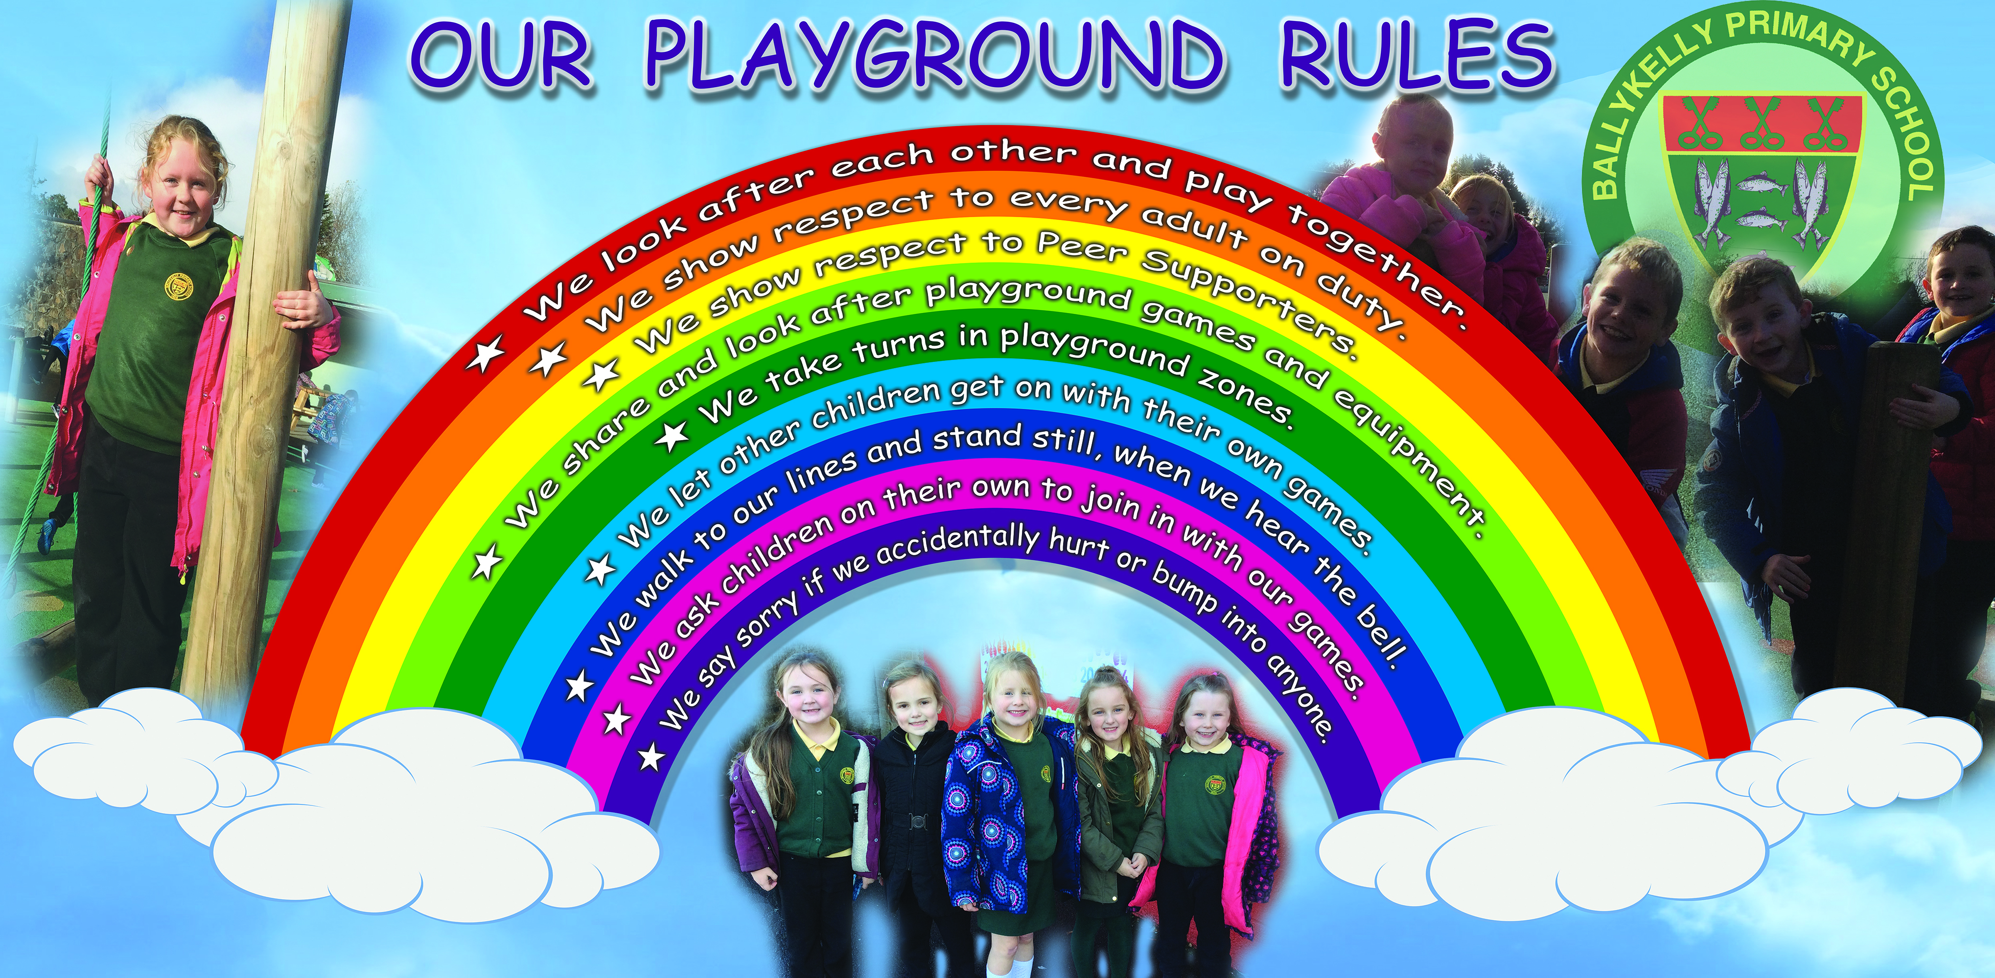
Bus Code of Conduct

- We follow the teacher or a designated adult to the bus
- We listen to the driver and follow his instructions
- We stay in our seats and wear our seatbelts on the bus
- We speak nicely to the other children on the bus
- We always tell the teacher if we are not going home on the bus

Canteen Code of Conduct

- We walk at all times
- We keep hands, feet, objects and comments to ourselves
- We raise our hands for attention
- We wait for instructions to leave our tables
- We show mutual respect between adults and children
- We display good manners at the dining table

Clubs Code of Conduct

- We show respect to the adult/s taking the club
- We are kind and respectful to other children who attend the club
- We may forfeit our right to attend the club if we do not uphold our Golden Rules during club activities

Appendix 2

De-escalation Strategies
Verbal communication operates at many levels within the teaching, caring and therapeutic processes at school. It is the most important skill staff have in helping children towards personal growth, and employed correctly is the most powerful de-escalation skill staff possess.

DO
1. Acknowledge the existence of a problem.
2. Give reassurance and offer support.
3. Be aware of voice quality, pitch and power. Make good use of pauses.
4. Paraphrase what is being said, and check back with the child that it is accurate.
5. Present facts or issues which may not be known to the child.
6. Use personalisation and former relationship patterns.
7. Put the onus on the child to resolve the situation, pointing out consequences, offering choices, and offering alternatives. Allow the child an ‘escape route’.
8. Use the word ‘we’ in discussion and explain that the solution can be a ‘together’ solution.
9. Offer “If I were you.... But it’s up to you” scenarios, if appropriate.
10. Identify the options with the child.

DON’T
1. Put the child in a position of no escape.
2. Use destructive criticism.
3. Remind the child of previous situations s/he would prefer to forget.
4. Use personal details of a child in front of the group.
5. Make unrealistic threats.
6. Make insensitive remarks.
7. Lose your temper.
8. Use “You will” statements.
9. Get involved in “You did – no I didn’t” arguments.
10. Argue with adults present.

Non-Verbal Behaviour
The primary reason for using and interpreting non-verbal signals is to reinforce positive behaviour quietly but frequently. Non-verbal signals can be used to de-escalate at a very early stage, or to signal a very low status adult involvement. If these signals are sent there will usually be a response. Similarly acknowledging non-verbal signals from within the group or from an individual enables early, low status staff intervention to occur.

DO
1. Make an attempt to look at an individual when you are making an important point.
2. Be aware of the signals which you give out by your body position and posture.
3. Try to sit down.
4. Nod your head to indicate attentiveness.
5. Smile to show agreement.
6. Be aware of the physical distance between yourself and others.
7. Raise your eyebrows to question.
8. Use hand, shoulder, and whole body gestures to support discussion.
9. Use physical contact as reassurance.
10. Seek signals that your message has been correctly received.

DON’T
1. Invade personal space.
2. Use staring threatening eye contact.
3. Stand over pupils in a threatening manner.
4. Appear to lack confidence.
5. Appear tense.
6. Be oblivious to signals within the environment.
7. Retaliate with physical gestures.
8. Use inappropriate physical contact with particular children.
9. Remain static.
10. Appear intimidated.

Group Control
Good group control is an integral aspect of effective work with children. If there is no order to group functioning neither individual or group objectives can be met.

DO
1. Be there on time to greet children. Starting and finishing on time are very important. This sends signals to children about the importance and value that the adult placed on the activity/lesson and makes colleagues’ tasks easier.
2. Be efficient. The more efficient you are the better you feel, the higher your level of confidence, the better things are likely to go.
3. Settle the group to its task with as little delay as possible.
4. Clearly state the expected task which must be relevant to the ability and interest levels of the children.
5. Check that you have been understood.
6. Try to be clear and decisive.
7. Address and resolve situations, don’t let them drag on or escalate without attention.
8. Be alert to what is going on and ensure that your attention is
distributed across the group.
9. Relate to all the children in the group by verbal exchange and social reinforcers, such as eye contact and nods.
10. Make use of the pupil management systems already in school.

DON’T
1. Be unclear and hurried in speech and actions.
2. Overreact.
3. Issue complicated instructions.
4. Show favouritism.
5. Be inconsistent.
6. Provoke by ridicule or sarcasm.
7. Have inappropriate expectations.
8. Belittle effort or endeavour.
9. Send children off in numbers that will be problematic for someone else.

Attitude and Approach
Staff members’ attitudes and approach in all situations affects the quality of relationships with pupils. In situations of rising tension staff attitude and approach is crucial. It can either improve or complicate the chance of success.
DO
1. Appear calm and collected if at all possible.
2. Be clear and firm about boundaries of acceptability.
3. Show a non-biased nature.
4. Be prepared to listen.
5. Know when the situation is in stalemate, don’t create a win/lose situation without it being a calculated decision.
6. Be flexible in thought and response.
7. Spontaneously provide a range of roles from dominance to reflective support.
8. Value people as individuals.
9. Be a sensitive, objective observer who can make valid diagnoses.
10. Trust others and perceive them as being able to solve their own problems.

DON’T
1. Be fooled into thinking you should always be able to deal with any situation.
2. Expect colleagues to do without your support.
3. Be insensitive.
4. Be unfair or hostile.
5. Use high status intervention where low status will suffice.
6. Don’t emphasise the situation out of all proportion.
7. Allow yourself to be wound up.
8. Carry on even when you know you are wrong.
9. Restart the argument or incident once calm has been achieved.
10. Use unnecessary peer group pressure.

Appendix 3
Regulating activities

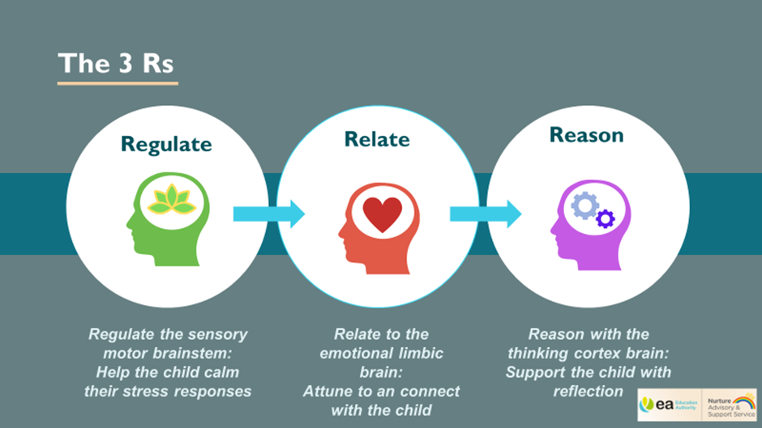

Appendix 4
Principles of a Nurturing School

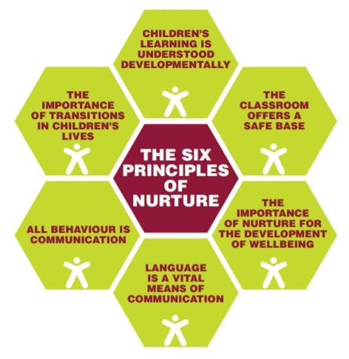

Appendix 5-Solution focused Behaviour Plan

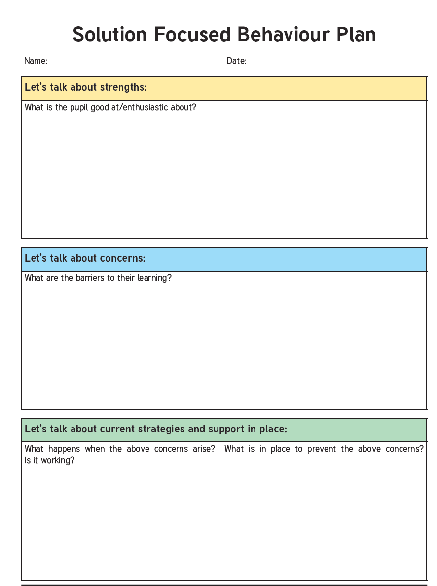

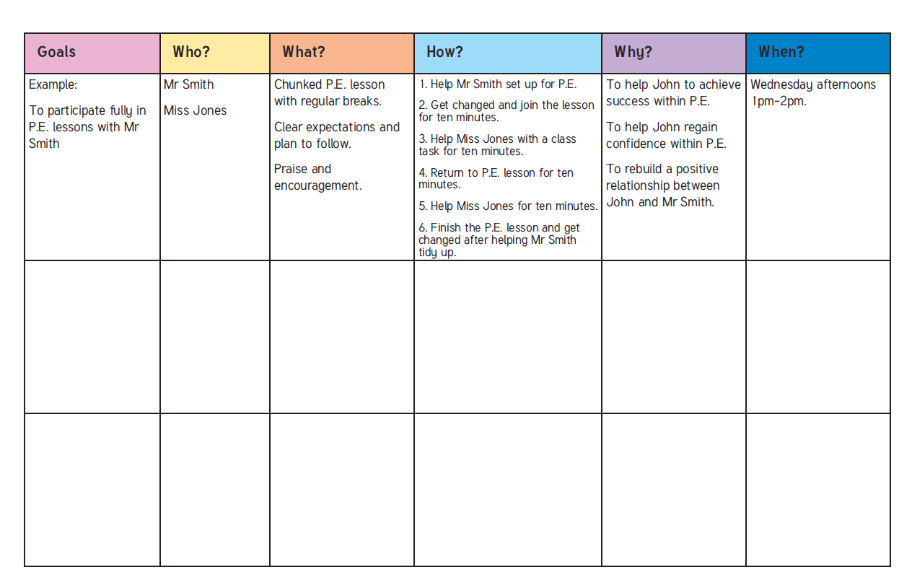

Appendix 6-Restorative Conversation Record
