News update

Wednesday 14th October 2020
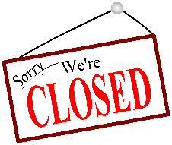
Department of Education update- School closure 19th October for two weeks.
Today, the Executive has announced that schools will have the half-term holiday break extended from Monday 19th October for two weeks. Schools will reopen on Monday 2nd November.
We have been told by DE that schools are closed to ALL pupils and remote learning will not take place.
During the week beginning 19th October, direct payments will be made to pupils in receipt of Free School Meals.

Our school will close at 1pm on Friday 16th October and, to support families, we will send home activity packs the children may wish to use over the extended break.
Halloween update
Children can come to school in non-uniform or wear their Halloween costumes on FRIDAY 16TH OCTOBER (SLC Thursday 15th October)
School will finish at 1pm as usual.

P3 and P4 Seesaw reminder
Please make sure you have signed up to Seesaw using the two QR codes sent home last week. The family code and the child’s home learning code. This will enable the teacher to keep you informed about your child’s learning and you can message the teacher with any queries. If you have mislaid these codes, please ring the class teacher on 028 77762864.
Future Intake
Don’t forget to complete the future intake survey sent by text link. The survey closes at 2pm on Friday 16th October.
After half-term we are starting our Healthy Snack Club which will give children a healthy snack during their mid-morning break. More information will follow on Monday 2nd November.
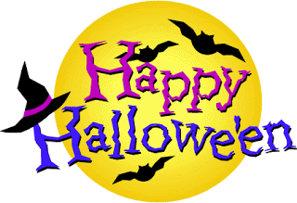
I want to thank all parents and carers for their support to date and wish you a safe and happy half-term during these very troubled times. We will endeavour to ensure our school is a safe and welcoming place for children to learn and develop on their return.

Mrs H Cole MBE
Principal

