Weekly news

Week beginning: Monday 14th December 2020
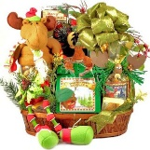
Roe Valley Community Foodbank
We raised £755 from our Christmas Jumper Day on 4th December and our Head Boy and Girl presented the cheque to Mrs Mairead McNulty, a representative from the Foodbank Committee and a former teacher at our school. This amount will bring lots of Christmas cheer to many needy families over the festive period. Thank you for your generosity and kindness.

Nursery & Primary 1 Admissions September 2021
On 18th December, EA will publish information on its website about the Admissions procedures and admissions criteria for schools.
The Go Live date for the digital admissions is Thursday 7th January 2021 at 12 noon. Applications will close on Friday 29th January 2021 at 12 noon.
We have made two short promotional films about our Nursery Unit and the School. You can watch these by visiting our school website, www.ballykellyps.co.uk and clicking on the Admissions tab. We have also included more information for prospective parents on our website and we will post updates on our Facebook page. Please share these links with family and friends.

Christmas updates
The Nursery, P1 and P2 children have recorded their little Christmas Plays and P1 & P2 parents can purchase the USB pen of the recording for £4. Please send the correct money in a named envelope to your child’s teacher.

The P3 & P4 children have recorded their Christmas songs for Cornfield Nursing Home and we will share this with parents as soon as we can. The children have also sent letters, a Christmas card and a gift to their friends in the Care Home.

KS 2 did a fantastic job with their Virtual Carol Service and you can view this on our school website www.ballykellyps.co.uk

Santa Claus came to our Woodland Trail on Thursday and Friday last week, the children were so excited and it lifted all our spirits seeing their happy faces. Thank you to Julie and Alison from the PTA for decorating the Trail and organising the special visitor to come on his sleigh!
School will close on Friday 18th December at 1pm for the Christmas break. School will re-open on Wednesday 6th January 2021 and we will be Week 1 on the dinner menu which can be found on our website in the Parent Area section.
The staff wish you all a very happy and safe Christmas and we pray 2021 will see an end to Covid-19 and we can all meet each other again soon.
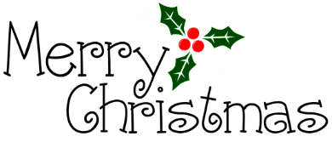
Mrs H Cole MBE
Principal

